**HP-LAUNCH SIMPLIFIED DWELLING HEATING NEEDS CALCULATIONS MODEL**

1. **Building energy simulation methods**

Building energy simulation is a vast field of research that started on the late 50’s and that is still highly active nowadays. Building energy simulations are mainly used to help taking design decisions, to analyse current designs and to forecast future building energy use. Building energy modelling methods can mainly be divided into three categories:

* White box model (physics-base)
* Black box model (data-driven)
* Grey box (hybrid)

White box model are based on the equations related to the fundamental laws of energy and mass balance and heat transfer. White box models can be differentiated in two types, distributed parameter models and lumped parameter models. Lumped parameter models simplifies the description of distributed physical systems into discrete entities that approximate the behaviour of a distributed system. The advantage of using lumped models is the decrease on simulation time (Ramallo-González et al.). White box model are of special interest for the design phase as they are used to predict and analyse the performance of the building envelope and building systems.

Black box models are based on the statistical relation between input and output system values. The statistical relation between input and output is based on actual data. The relation between the parameters can differ based on the amount of data and the method used to analyse the relation. Currently, there is a large and active field of research about statistical models that are used on black box models (Coacley et al.). Black box models are of special interest when there is a large amount of actual input and output data available.

Grey box model are an hybrid model form that aim to combine the advantages of both systems. In order to use them it is necessary to implement some equations and it is also required to have actual data of inputs and outputs.

1. **White box lumped model: RC network**

The objective of the house model for this project is to serve as test environment for a heat pump model, what means that the house model is intended as a tool to help taking building systems design decisions. The house heating needs calculation model implemented for this project is a white box lumped model. Specifically, it is a RC network model consisting of resistances (R) and capacities (C). The RC network model is based on electrical systems analogy. The simulation of thermodynamic systems characterizing building elements as resistances or capacities allows to simplify the model while maintaining a high simulation results accuracy (Bagheri et al., Bacher et al.).

There are several types of RC models, the most common being 3R4C models and 3R2C models which are applied on the outer and internal wall. For the simulation of simple house buildings 3R2C models perform as accurate as more complex 3R4C models (Fraisse et al. ). Taking into account that one of the objectives for this project is to obtain a fast but accurate simulation of a simple dwelling the 3R2C network model appeared as starting point. In the 3R2C model two indoor temperature nodes in the dwelling with capacities (usually an air and a wall temperature) and a well-known outdoor temperature are present. Between these 3 temperature nodes 3 heat transfer resistances are present. However the direct heat transfer between the inner walls and the outdoor air is low. Moreover, uncertainties are present about heat transfer coefficients between walls and indoor air, different indoor temperatures in the house rooms and the ground temperature which deviates from the outdoor temperature. In addition occupancy behaviour varies strongly. For that reason we have made a further simplification to a 2R2C model. In section 4 it is shown that this dwelling model delivers a reliable annual energy consumption.

1. **HP-Launch house model**

The dwelling model has been developed making use of Matlab/Simulink. In the Simulink model it is possible to define the dwelling characteristics, the dwelling use data and the climate data. With some of this information the model resistances and capacities are built on a Matlab script. The resistances and capacities values are used during the year energy simulation.

In sections 3.1 to 3.3 the information provided to make the simulation is presented. In section 3.4 it is explained how the 2R2C network model has been build. The Matlab script can be found in the appendix I.

* 1. Dwelling characteristics information

The dwelling characteristics taken into account in order to define the model resistances and capacities are presented in figure 1. The ventilation rate n in ach (air changes per hour) is based on a mechanical ventilation rate of 150 m3/h for kitchen, toilet and bathroom) by regulations.

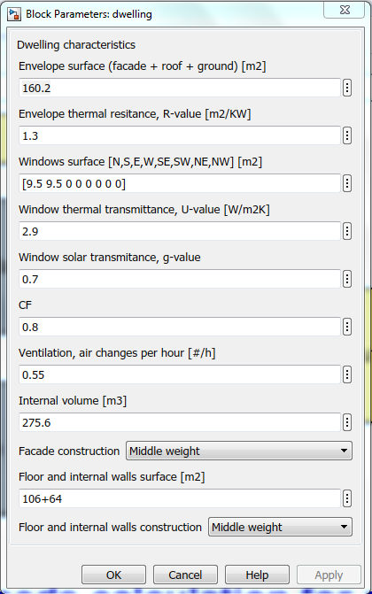

Figure 1. Dwelling characteristics model information.

* 1. Dwelling use data

The dwelling use data define the schedule to be used to calculate the dwelling internal heat and the thermostat set-points. The thermostat signal is communicated to the heat pump model. The information use to define the dwelling use is presented in Figure 2.

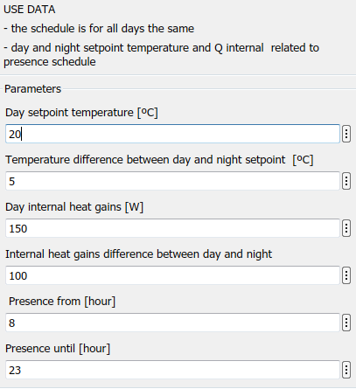

Figure 2. Dwelling use model information

* 1. Climate data

The hourly data about the outdoor temperature and the solar radiation is extracted from the NEN5060:2018 norm. This norm defines a typical meteorological year using the Finkelstein-Schafer statistical method with the climate data of 20 years period (1996-2015). The meteorological data used by the norm is updated once every 5 years.

The typical meteorological year data is the one to be used when calculating the typical energy use of the heating installation. The NEN norm offers also three other hourly climate datasets, each one with a different percentual deviation from the typical meteorological year: 1%, 3% and 5%. These data sets are to be used when analysing the response of the heating installation under more extreme climate conditions. This is usually done for design installation purposes. The total energy use calculated with these other datasets will not give a reliable value for calculating the typical energy use. In figure 3 it is shown that is it possible to choose between the four different NEN climate datasets.

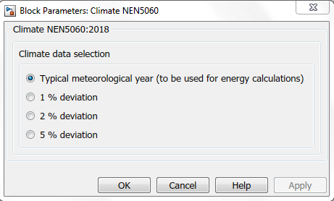

Figure 3. Climate data selection

In a pre-process the global incident radiant is calculated for North, South, East, West, North-West, North-East, South-West and South-East orientations of the façade in Matlab. The model from Perez is applied for the exchange. In this model the irradiation is split into a direct and diffuse terms.

Appendix II shows the applied files.

* 1. Dwelling model

The 2R2C structure implemented in the Simulink model is shown in Figure 4.

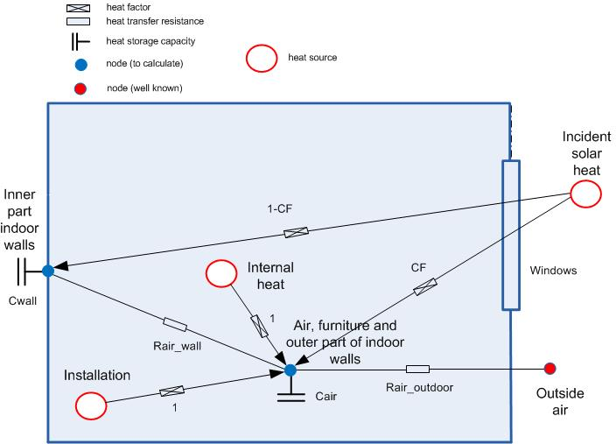

Figure 4. Schematic of the dwelling model

There are two capacities Cair and Cwall and two resistances Rair_wall and Rair_outdoor. The incident solar heat is divided between Cwall and Cair by the convection factor CF. It is assumed that both internal heat (lighting, occupancy and electric devices) and supplied heat (installation) are fully released at the air node.

It is assumed that furniture and the surface part of the walls have the same temperature as the air and the wall mass is divided between the air and wall mass. Thus, the capacity of the air node consists of the air capacity, furniture capacity and capacity of a part of the walls. Appendix I presents the coefficients in the dwelling model. In the resistance Rair_outdoor the influence of heat transmission through the outdoor walls and natural ventilation is taken into account.

For the air and wall nodes the following energy balances can be set up:

$$C_{air}\frac{dT_{air}}{dt}=\frac{(T_{outdoor}-T_{air})}{R_{air-outdoor)}}+\frac{(T_{wall}-T_{air})}{R_{air-wall)}}+Q_{inst}+Q_{internal}+CF.Q_{solar}$$

And

$$C_{wall}\frac{dT_{wall}}{dt}=\frac{(T_{air}-T_{wall})}{R_{air-wall)}}+(1-CF).Q_{solar}$$

Qsolar is the incident solar radiation:

$$Qsolar=g.\sum{(Aglass.qsolar)}$$

With qsolar=solar radiation on the outdoor walls [W/m2]

g = g value of the glass (=ZTA in dutch) [0..1]

These equations are implemented as differential equations in Simulink in a so-called State-Space block. See Figure 5.

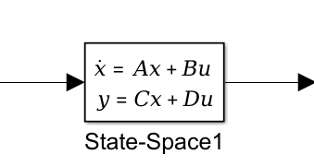

Figure 5. State Space block.

Wherein x and y is a vector containing the air and wall temperatures and u is a vector containing Toutdoor, Qinst, Qinternal and Qsolar. The coefficients in the matrices A, B, C and C are calculated from the R’s and C’s. See line numbers 45 to 52 of the ‘init_dwelling’ script in the Annex.

In the dwelling model Qinst is proposed to be well-known. Qinst is estimated by the control block in the installation model of the Simulink model.

**4. Model results verification**

In order to test the model we have used the data from the document document *Voorbeeldwoningen 2011 Bestaande bouw* published by Agentschap NL. We have run the model for a detached house building build between 1975 and 1991 and for row house building build between 1975 and 1991.

For the detached house the model calculates a sum of the yearly energy needs of 10545 kWh. The document *Voorbeeldwoningen 2011* gives a calculated energy use for heating and hot water of 1542 m3 gas. The average gas consumption of hot tap water on a Dutch household is 300 m3gas.

We assume a combustion (under) value ho=35.2 MJ/m3 gas. Taking into consideration a heating system efficiency of 0.9, the energy need is 10843 kWh.

$$\left(1542-300\right)x35200/3600x0.9=10843 kWh$$

For the row house the model calculates a sum of the yearly energy needs of 19776 kWh. The sidewalls have been considered as adiabatic walls. The document *Voorbeeldwoningen 2011* gives a calculated energy use for heating and hot water of 2616 m3 gas. The average gas consumption of hot tap water on a Dutch household is 300 m3gas. Taking into consideration a heating system efficiency of 0.9, the energy need is 20219 kWh.

$$\left(2616-300\right)x35200/3600x0.9=20129 kWh$$

The results gives an indication that the model is on the right result range.

**References**

AgenschapNL (2011) Voorbeeldwoningen 2011 Bestaande bouw, Agenschap NL, Sittard, the Netherlands.

Bacher P., Madsen H. (2011) Identifying suitable models for the heat dynamics of buildings, Energy and Buildings, 43-11, pp. 1511-1522.

Bagheri A., Feldheim V. and Ioakimidis C. S. (2018) On the Evolution and Application of the Thermal

Network Method for Energy Assessments in Buildings, Energies, 11, pp. 890.

Coakley D., Raftery P. and Keane M. (2014), A review of methods to match building energy simulation models to measured data, Renewable and Sustainable Energy Reviews, 37, pp.123-141.

Fraisse G., Viardot C., Lafabrie O. and Achard G. (2002) Development of a simplified and accurate building model based on electrical analogy, Energy and Buildings, 34-10, pp. 1017-1031.

Koninklijk Nederlands Normalisatie‐instituut (2018) NEN5060:2018, Hygrothermal performance of buildings ‐ Climatic reference data.

Ramallo-González A.P., Eames M.E. and Coley D. A. (2013) Lumped parameter models for building thermal modelling: An analytic approach to simplifying complex multi-layered constructions, Energy and Buildings, 60, pp. 174-184.

**Appendix I. Code Initialization file ‘init_dwelling’**

1 % Initialization Dwelling

2 % 3 September 2018 (cleaned version from 10 July 2018)

3 % Arie Taal, Baldiri Salcedo HHS

4

5

6 %% Predefined variables

7

8 rho_air=1.20; % density air in [kg/m3]

9 c_air=1005; % specific heat capacity air [J/kgK]

10 alpha_i_facade=8;

11 alpha_e_facade=23;

12 alpha_internal_mass=8;

13

14 %% Variables from Simulink model, dwelling mask

15

16 % Floor and internal walls construction.

17 % It is possible to choose between light, middle or heavy weight construction

18

19 if N_internal_mass==1 % Light weight construction

20

21 c_internal_mass=840; % Specific heat capacity construction [J/kgK]

22 th_internal_mass=0.1; % Construction thickness [m]

23 rho_internal_mass=500; % Density construction in [kg/m3]

24

25 elseif N_internal_mass==2 % Middle weight construction

26

27 c_internal_mass=840; % Specific heat capacity construction [J/kgK]

28 th_internal_mass=0.1; % Construction thickness [m]

29 rho_internal_mass=1000; % Density construction in [kg/m3]

30

31 else % Heavy weight construction

32

33 c_internal_mass=840; % Specific heat capacity construction [J/kgK]

34 th_internal_mass=0.2; % Construction thickness [m]

35 rho_internal_mass=2500; % Density construction in [kg/m3]

36 end

37

38 Aglass=sum(glass); % Sum of all glass surfaces [m2]

39 V_internal_mass=A_internal_mass*th_internal_mass; % Volume floor and internal walls

construction [m3]

40 qV=(n*V_dwelling)/3600; % Ventilation, volume air flow [m3/s]

41 qm=qV*rho_air; % Ventilation, mass air flow [kg/s]

42

43 %% Dwelling temperatures calculation

44

45 % Calculation of the resistances

46 Rair_wall=1/(A_internal_mass*alpha_internal_mass); % Resistance indoor air-wall

47 U=1/(1/alpha_i_facade+Rc_facade+1/alpha_e_facade); % U-value indoor air-facade

48 Rair_outdoor=1/(A_facade*U+Aglass*Uglass+qm*c_air); % Resitance indoor air-outdoor air

49

50 % Calculation of the capacities

51 Cair=rho_internal_mass*c_internal_mass*V_internal_mass/2+ rho_air*c_air*V_dwelling; % Capacity indoor air + walls

52 Cwall=rho_internal_mass*c_internal_mass*V_internal_mass/2% Capacity walls

53

54 % State space equations

55 % dTair/dt=a11.Tair+a12.Twall+b11.Toutdoor+b12.Qinst+b13.Qinternal+b14.Qsolar

56 % dTwall/dt=a21.Tair+a22.Twall+b21.Toutdoor+b22.Qinst+b23.Qinternal+b24.Qsolar

57

58 % Calculation of the matrix elements

59 a11=-1/(Rair_wall*Cair)-1/(Rair_outdoor*Cair);

60 a12=1/(Rair_wall*Cair);

61 a21=1/(Rair_wall*Cwall);

62 a22=-1/(Rair_wall*Cwall);

63

64 b11=1/(Rair_outdoor*Cair); % Toutdoor

65 b12=1/Cair; % Q installation

66 b13=1/Cair; % Q internal heat gains

67 b14=CF/Cair; % Q solar radiation

68

69 b21=0; % Toutdoor

70 b22=0; % Q installation

71 b23=0; % Q internal heat gains

72 b24=(1-CF)/Cwall % Q solar radiation

73

74 % Calculation of the matrices

75 A=[a11 a12 ; a21 a22];

76 B=[b11 b12 b13 b14 ; b21 b22 b23 b24];

77 C=[1 0 ; 0 1 ]; % dummy T=T

78 D=[0 0 0 0; 0 0 0 0]; % dummy

**Appendix II. Codes m-files for calculation solar irradiation on inclined surfaces**

1. Exchange_NEN5060_3.m

1 % Exchange_NEN5060_3.m

2 %

3 % Exchange of NEN5060 data in climate files for Matlab/ Simulink

4 %

5 % Exchange of NEN5060_2008 data in Excel format to a mat-file with irradiation

6 % for irradiation on S, SW, W, NW, N, NE, E, SE and horizontal

7 % and Toutdoor

8 % Irradiation can be used for solar irradiation on windows

9 % version September 17th 2018

10 % by Arie Taal THUAS (The Hague University of Applied Sciences)

11

12 rground=0; % ground reflection is ignored

13 for k=1:4

14

15 if k==1

16 [NUM,TXT,RAW]=xlsread('NEN5060-A2.xls',1); % this file is part of NEN 5060 2008

17 elseif k==2

18 [NUM,TXT,RAW]=xlsread('NEN5060-B2.xls',1);

19 elseif k==3

20 [NUM,TXT,RAW]=xlsread('NEN5060-B2.xls',2);

21 else

22 [NUM,TXT,RAW]=xlsread('NEN5060-B2.xls',3);

23 end

24

25 t=((1:8760)'-1)*3600;

26 dom=NUM(:,3); % day of month

27 hod=NUM(:,4); % hour of day

28 qglob_hor=NUM(:,5);

29 qdiff_hor=NUM(:,6);

30 qdir_hor=NUM(:,7);

31 qdir_nor=NUM(:,8);

32 Toutdoor=NUM(:,9)/10;

33 phioutdoor=NUM(:,10);

34 xoutdoor=NUM(:,11)/10;

35 pdamp=NUM(:,12);

36 vwind=NUM(:,13)/10; % at 10 m height

37 dirwind=NUM(:,14);

38 cloud=NUM(:,15)/10;

39 rain=NUM(:,16)/10;

40

41 for j=1:9

42 if j<9

43 gamma=45*(j-1);

44 beta=90;

45 else

46 gamma=90;

47 beta=0;

48 end

49 for i=1:8760

50 E(i,j)=qsun(t(i),qdiff_hor(i),qdir_nor(i),gamma,beta,rground);

51 end

52 end

53 qsunS=horzcat(t,E(:,1));

54 qsunSW=horzcat(t,E(:,2));

55 qsunW=horzcat(t,E(:,3));

56 qsunNW=horzcat(t,E(:,4));

57 qsunN=horzcat(t,E(:,5));

58 qsunNE=horzcat(t,E(:,6));

59 qsunE=horzcat(t,E(:,7));

60 qsunSE=horzcat(t,E(:,8));

61 qsunhor=horzcat(t,E(:,9));

62 Tout=horzcat(t,Toutdoor);

63 phiout=horzcat(t,phioutdoor);

64 xout=horzcat(t,xoutdoor);

65 pout=horzcat(t,pdamp);

66 vout=horzcat(t,vwind);

67 dirvout=horzcat(t,dirwind);

68 cloudout=horzcat(t,cloud);

69 rainout=horzcat(t,rain);

70

71 if k==1

72 save NEN5060_A2 t Tout qsunS qsunSW qsunW qsunNW qsunN qsunNE qsunE qsunSE ...

73 qsunhor Tout phiout xout pout vout dirvout cloudout rainout

74 elseif k==2

75 save NEN5060_B2_1 t Tout qsunS qsunSW qsunW qsunNW qsunN qsunNE qsunE qsunSE ...

76 qsunhor Tout phiout xout pout vout dirvout cloudout rainout

77 elseif k==3

78 save NEN5060_B2_2 t Tout qsunS qsunSW qsunW qsunNW qsunN qsunNE qsunE qsunSE ...

79 qsunhor Tout phiout xout pout vout dirvout cloudout rainout

80 elseif k==4

81 save NEN5060_B2_3 t Tout qsunS qsunSW qsunW qsunNW qsunN qsunNE qsunE qsunSE ...

82 qsunhor Tout phiout xout pout vout dirvout cloudout rainout

83 end

84 end

1. qsun.m

1 % qsun Calculates the irradiation on a outer surface

2 %

3 % SYNTAX: E=irrad(Dh,En,iday,LST,gamma,beta,rground)

4 %

5 % OUTPUT: global irradiation on a surface

6 %

7 % Splitted irradiation

8 % E(1)= diffuse solar irradiation on an inclined surface

9 % E(2)= direct solar irradiation on an inclined surface

10 % E(3)= total solar irradiation on an inclined surface

11 % E(4)= total solar irradiation on a horizontal surface

12 %

13 % INPUT:

14 % (scalar) Dh = diffuse horizontal irradiation [W/m2]

15 % (scalar) En = direct normal irradiation [W/m2]

16 % (scalar) t = time seconds after midnight 1 january

17 % (scalar) gamma = azimuth angle of the surface,

18 % east:gamma = -90, west:gamma = 90

19 % south:gamma = 0, north:gamma = 180

20 % (scalar) beta = inclination angle of the surface,

21 % horizontal: beta=0, vertical: beta=90

22 %

23 % default geographical position: De Bilt

24 % default ground reflectivity (albedo): 0.2

25 %

26 % EXAMPLE: E=irrad(800,200,201,12,0,45)

27 % ANSWER: E=1.0e+003 *

28 % 0.8569 0.1907 1.0759 0.9684

29 %

30 % REF: Perez (zie Solar Energy volume 39 no. 3)

31 %

32 % Adapted version from Eindhoven University of Technology: JvS feb 2002

33

34 function EW=qsun(tclim,Dh,En,gamma,beta,rground);

35

36 %(scalar) iday = day of the year (1-365)

37 % (scalar) LST = Local Standard time (0 - 24) [hour]

38

39 iday=1+floor(tclim/(24*3600));

40 LST=floor(rem( (tclim/3600),24));

41

42

43 % L = Latitude [graden]

44 L=52.1;

45 % LON = Local Longitude [graden] oost is positief

46 LON=5.1;

47 % LSM = Local Standard time Meridian [graden] oost is positief

48 LSM=15;

49 % rground = albedo

50 % rground=0.2;

51

52 r=pi/180;

53 L=L*r;

54 beta=beta*r;

55 theta=2*pi*(iday-1)/365.25;

56 el=4.901+0.033*sin(-0.031+theta)+theta;

57 % declination

58 delta=asin(sin(23.442*r)*sin(el));

59 q1=tan(4.901+theta);

60 q2=cos(23.442*r)*tan(el);

61 % equation of time

62 ET=(atan((q1-q2)/(q1*q2+1)))*4/r;

63 AST=LST+ET/60-(4/60)*(LSM-LON);

64 h=(AST-12)*15*r;

65

66 % hai=sin(solar altitude)

67 hai=cos(L)*cos(delta)*cos(h)+sin(L)*sin(delta);

68

69 E(1)=0; E(2)=0; E(3)=0; E(4)=0;

70 if hai>0,

71

72

73 % salt=solar altitude

74 salt=asin(hai);

75 phi=acos((hai*sin(L)-sin(delta))/(cos(salt)*cos(L)))*sign(h);

76 gam=phi-gamma*r;

77

78 % cai=cos(teta)

79 cai=cos(salt)*cos(abs(gam))*sin(beta)+hai*cos(beta);

80 % teta = incident angle on the tilted surface

81 teta=acos(cai);

82 % salts=solar altitude for an inclined surface

83 salts=pi/2-teta;

84

85 % Perez (zie Solar Energy volume 39 no. 3)

86 % berekening van de diffuse straling op een schuin vlak

87 % Approximatin of A and C, the solid angles occupied by the circumsolar region,

88 % weighed by its average incidence on the slope and horizontal respectively.

89 % In the expression of diffuse on inclined surface the quotient of A/C is

90 % reduced to XIC/XIH. A=2*(1-cos(beta))*xic, C=2*(1-cos(beta))*xih

91 % gecontroleerd okt 1996 martin de wit

92

93 % alpha= the half-angle circumsolar region

94 alpha=25*r;

95

96 if salts<-alpha,

97 xic=0;

98 elseif salts>alpha,

99 xic=cai;

100 else

101 xic=0.5*(1+salts/alpha)*sin((salts+alpha)/2);

102 end

103

104 if salt>alpha,

105 xih=hai;

106 else

107 xih=sin((alpha+salt)/2);

108 end

109

110 epsint=[1.056 1.253 1.586 2.134 3.23 5.98 10.08 999999];

111 f11acc=[-0.011 -0.038 0.166 0.419 0.710 0.857 0.734 0.421];

112 f12acc=[0.748 1.115 0.909 0.646 0.025 -0.370 -0.073 -0.661];

113 f13acc=[-0.080 -0.109 -0.179 -0.262 -0.290 -0.279 -0.228 0.097];

114 f21acc=[-0.048 -0.023 0.062 0.140 0.243 0.267 0.231 0.119];

115 f22acc=[0.073 0.106 -0.021 -0.167 -0.511 -0.792 -1.180 -2.125];

116 f23acc=[-0.024 -0.037 -0.050 -0.042 -0.004 0.076 0.199 0.446];

117

118 % determination of zet = solar zenith angle (pi/2 - solar altitude).

119 zet=pi/2-salt;

120

121 % determination of inteps with eps

122 inteps=1;

123 if Dh>0,

124 eps=1+En/Dh;

125 i=find(epsint>=eps);

126 inteps=min(i);

127 end

128

129 % calculation of inverse relative air mass

130 airmiv=hai;

131 if salt<10*r,

132 airmiv=hai+0.15*(salt/r+3.885)^(-1.253);

133 end

134

135 % calculation of extraterrestrial radiation

136 Eon=1370*(1+0.033*cos(2*pi*(iday-3)/365));

137

138 % delta is "the new sky brightness parameter"

139 delta=Dh/(airmiv*Eon);

140

141 % determination of the "new circumsolar brightness coefficient

142 % (f1acc) and horizon brightness coefficient (f2acc)"

143 f1acc=f11acc(inteps)+f12acc(inteps)*delta+f13acc(inteps)*zet;

144 f2acc=f21acc(inteps)+f22acc(inteps)*delta+f23acc(inteps)*zet;

145

146 % determination of the diffuse radiation on an inclined surface

147 E(1)=Dh*(0.5*(1+cos(beta))*(1-f1acc)+f1acc*xic/xih+f2acc*sin(beta));

148 if E(1)<0,

149 E(1)=0;

150 end

151

152 % horizontal surfaces treated separately

153 % beta=0 : surface facing up, beta=180(pi) : surface facing down

3/22/19 10:05 AM E:\NEN5060\qsun.m 4 of 4

154 if beta>-0.0001 & beta<0.0001,

155 E(1)=Dh;

156 end

157 if beta>(pi-0.0001) & beta<(pi+0.0001),

158 E(1)=0;

159 end

160

161 % Isotropic sky

162 % E(1)=0.5*(1+cos(beta))*Dh;

163

164 % direct solar radiation on a surface

165 E(2)=En*cai;

166 if E(2)<0.0,

167 E(2)=0;

168 end

169

170 % the ground reflected component: assume isotropic

171 % ground conditions.

172 Eg=0.5*rground*(1-cos(beta))*(Dh+En*hai);

173

174 % global irradiation

175 E(4)=Dh+En*hai;

176

177 % total irradiation on an inclined surface

178 E(3)=E(1)+E(2)+Eg;

179

180 end

181

182 EW=E(3);